**Physics 11A – Eiteneer**

**Lab: Forces in Equilibrium**

**Online version**

**Names:____________________________________________________________________________________**

**PURPOSE**

To experimentally verify the vector nature of force.

**INTRODUCTION**

Newton’s Laws assert that if a particle is in equilibrium then the total force on it must vanish, i.e. the vector sum of the applied forces must be equal to zero, 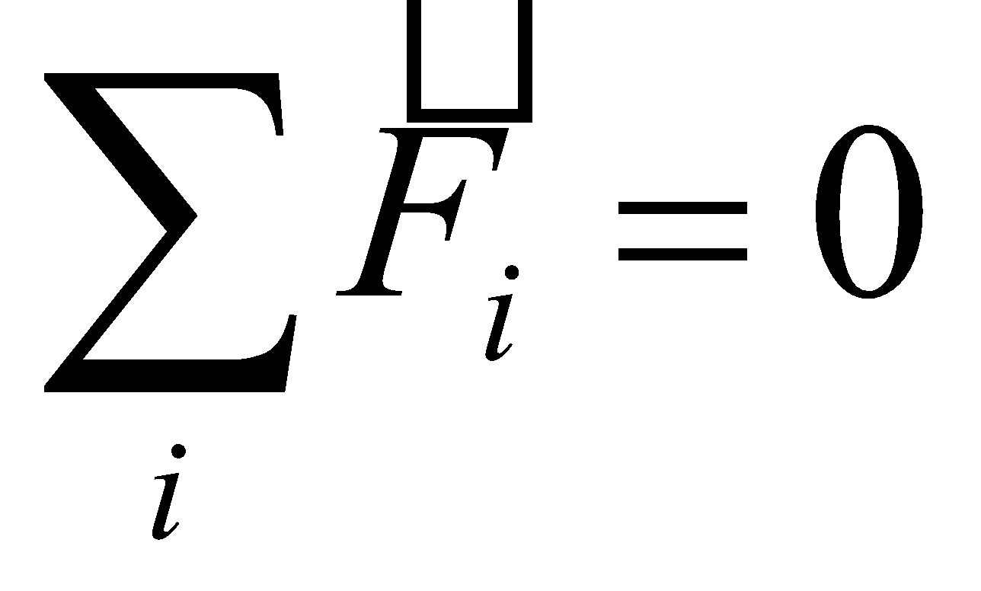.

The purpose of this experiment is to test that assertion. The “particle” in question is a knot of string that is being pulled upon from three directions, as shown in the figure below. We will measure then tensions *Ti*in the three strings (*i*=1,2,3), and the angles *θi* at which the strings pull. From these quantities we compute the *x-* and *y*- components of the force vector applied to the knot by each string, denoted by *Fix*and *Fiy*. These will then be added, forming the total 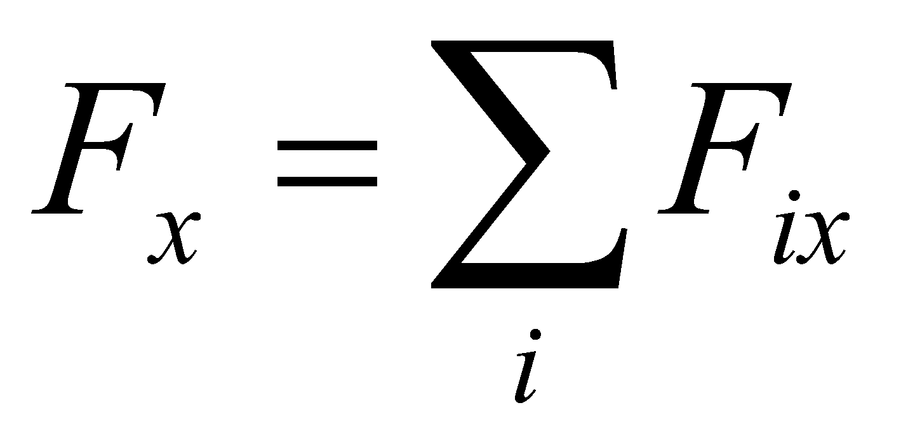 and 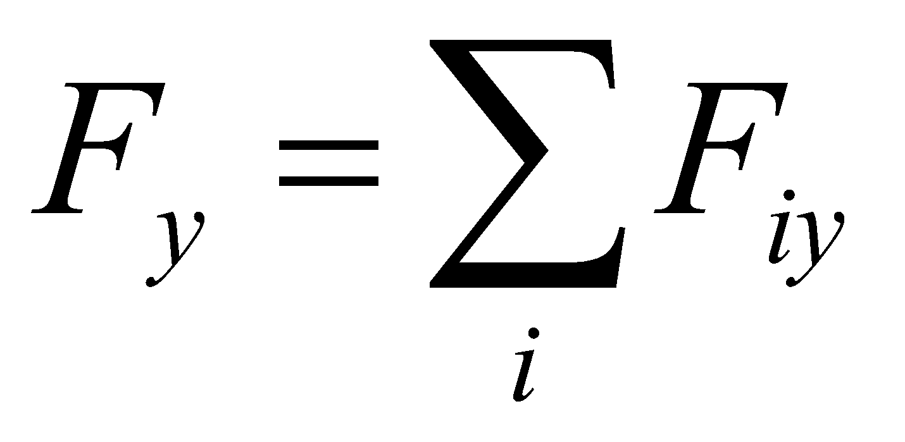, and the results compared with zero. If Newton’s Laws are right, we should find that these two sums are equal to zero, within the uncertainty of the experiment.

**MATERIALS AND EQUIPMENT**

|  |  |
| --- | --- |
| Force table | Ruler |
| Hanging mass set | Plastic ring |
| 3 super pulleys with clamps | Level |
| String or thread | Scale |

**PROCEDURE**

1. The drawings below show the top view and the side view, respectively, of a sample set up. The force table is basically a circle, divided into 360 degrees. You will be using given angles and forces.

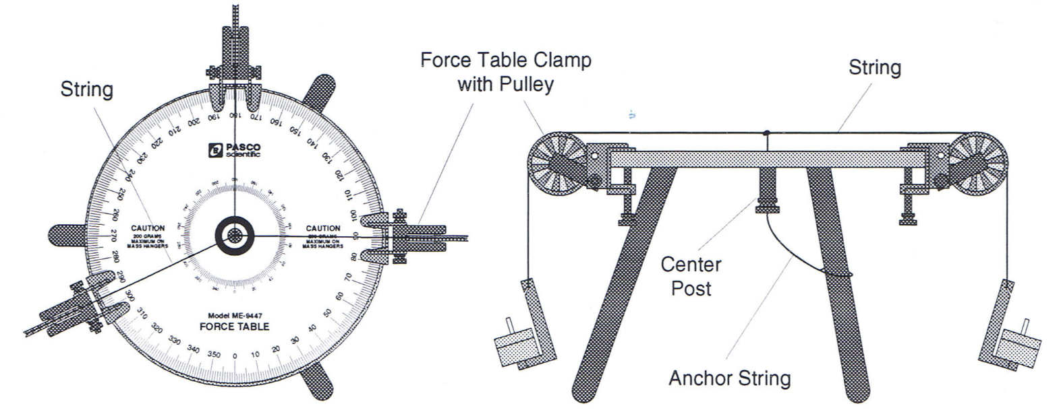

1. The goal of this lab is to create an equilibrium situation. We are going to tie three strings to a small plastic ring. These strings then pass through frictionless (virtually ideal) pulleys, and plastic hangers are attached to the other end of each string. Small masses are placed on the hangers until equilibrium is reached, as shown in the figures.
2. The forces in the setup (acting on the plastic ring) are effectively tension forces, even though we are going to be adjusting the masses of the handing weights. Thus, our forces will be measured in “grams” rather than newtons. This is called a “convenience unit” – units that can be directly read from the experiment. Rather than using unit conversions to convert the units for each measurement, we are going to save the conversion until the end (or not convert the units at all), thus eliminating a lot of “busywork.” In this particular experiment, there is one more reason why the forces can be measured in grams. In one or two sentences, explain what that one reason is (besides the ease of using “convenience units.”
3. We are going to start with two known forces (masses), and determine the third force (mass) graphically, algebraically, and experimentally. The mass that is hanging on the string at 0° is 55 (counting the hanger itself). The mass that is hanging on the string at 160° is 105 g (counting the hanger). Assume all of these values are exact.
4. In order to create an equilibrium situation, the pulleys have to be adjusted so that the strings are as low as possible above the table but not touching the pulley clamp or the table. The strings also have to be parallel to the surface of the force table, which is also parallel to the floor.
5. We will call the force associated with the 50 gram disk/hanger as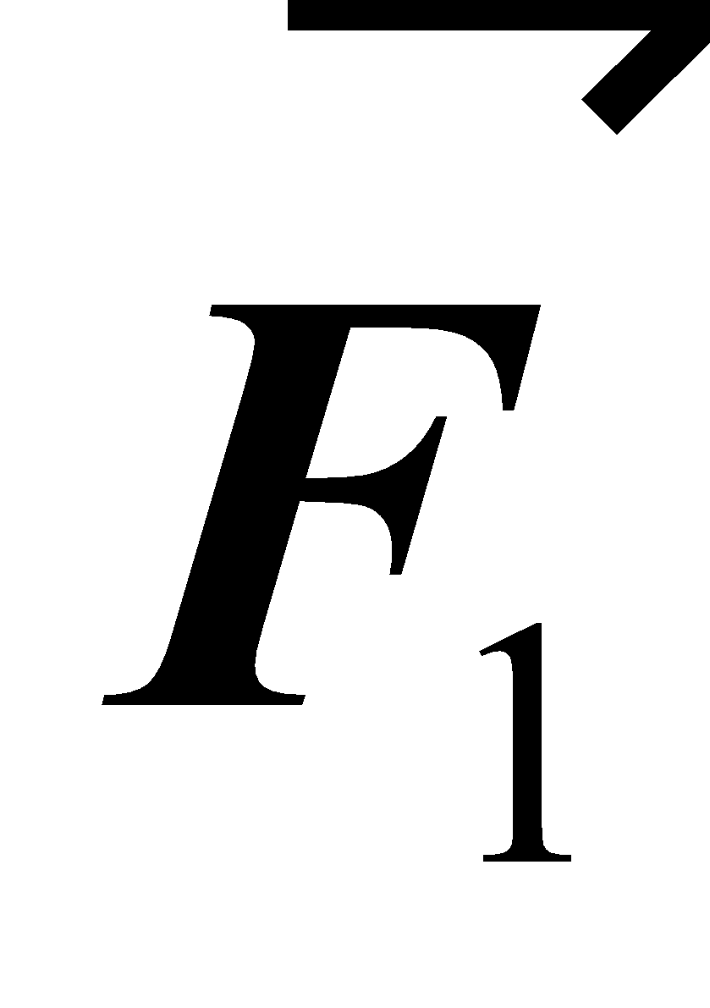 and the force associated with the second disk/hanger as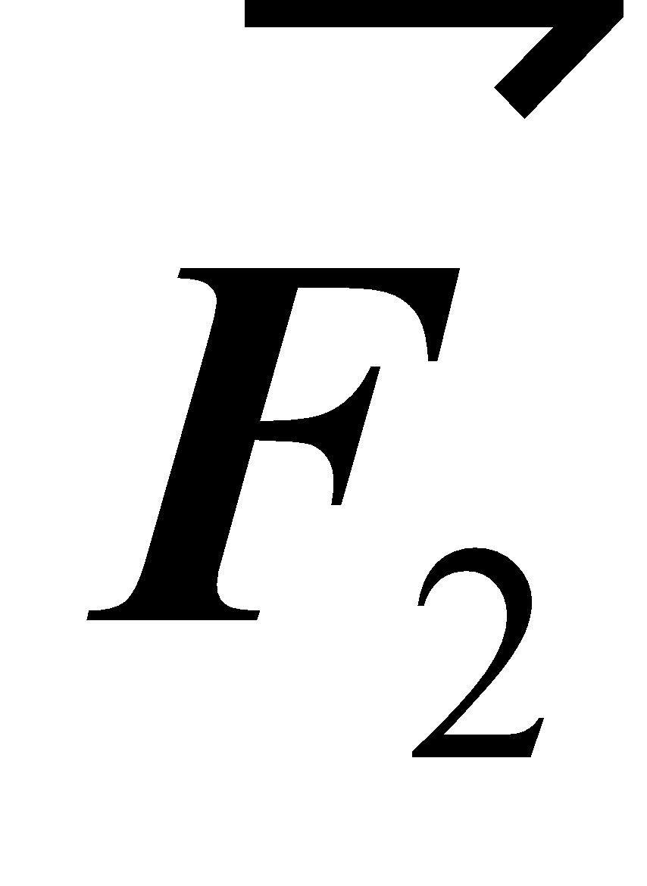. We will call the third (unknown) force 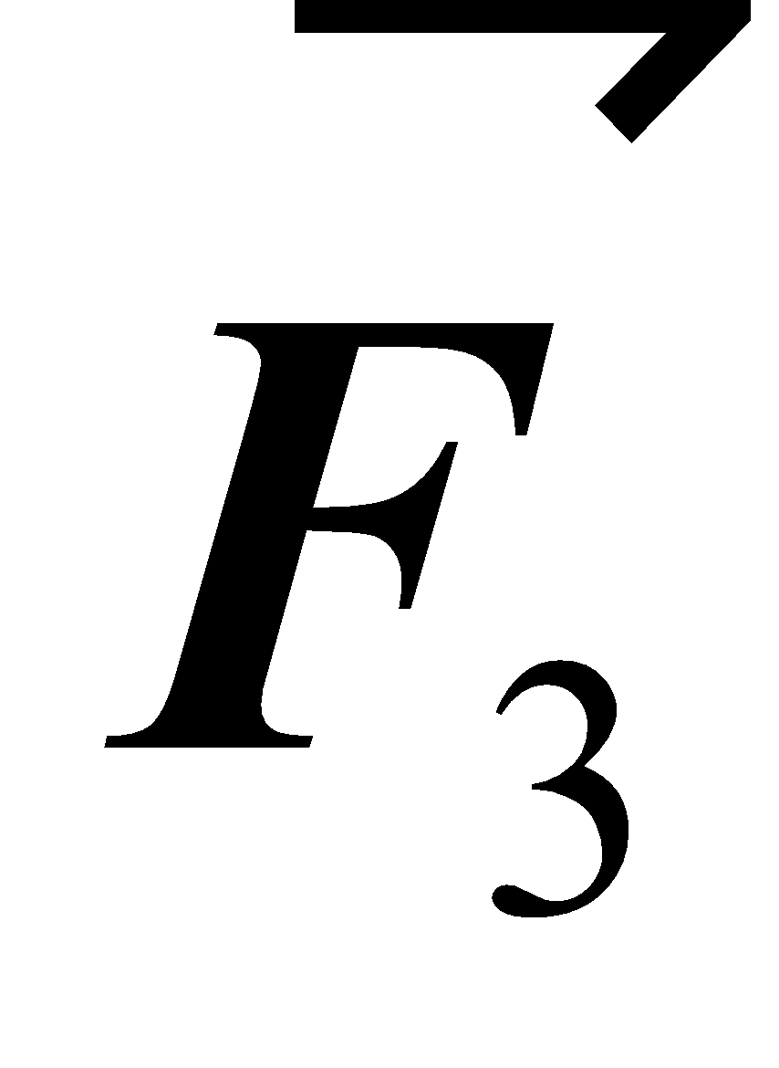.
6. On the protractor template sheet (found on Canvas), draw vector arrows for  and . You will need a coordinate system and a scale conversion factor. Place the origin of the coordinate system at the center of the template with 0o as the +x-axis and use an appropriate scale. The scale must be chosen in such a way that your drawing fits completely within the protractor template. Make sure that the vectors you are drawing visually stand out, and not blend in with the protractor template.
7. Graphically add  and . Then draw the third force  in such as way that its tip is at the origin. Hint: you should have a triangle with one vertex at the origin. Don’t forget to attach your graph when turning in this lab.
8. Now, add  and  algebraically, and thus determine  that would assure that the three forces add up to zero. In other words, use Newton’s First Law, 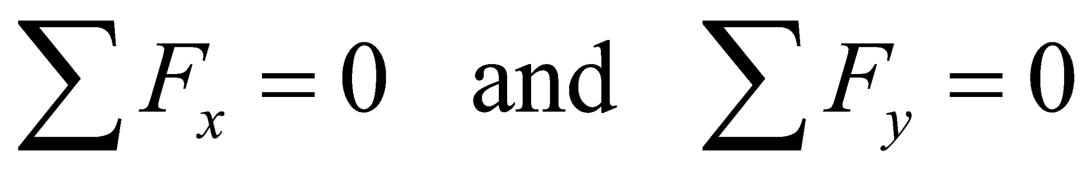. Show all steps!
9. Once we have determined  graphically and algebraically, we need to do it experimentally. What that means in terms of physical setup, is that we are effectively figuring out 1) where the third pulley needs to be placed, and 2) how much mass we should place on its hanger so that the system is in equilibrium and the plastic ring is directly above the center of the table. Here is a hint: when the system is in equilibrium, you can gently nudge the plastic ring and see if it returns to the center position. If not, some adjustments need to be made to the magnitude and/or direction of the third force.
10. Look at the two photographs posted on Canvas, and determine the position (angle) of the third string. Record it here:

**θ3** = ________________

The force (mass) was experimentally determined to be 57 g.

1. Using the **experimental value** for the magnitude and direction of, fill out the following table:

|  |  |  |
| --- | --- | --- |
|  | **x-component** | **y-component** |
| ***F1*** |  |  |
| ***F2*** |  |  |
| ***F3*** |  |  |
| **Sum** |  |  |

1. Let’s check to see how close our experimental values were to the calculated values. One convenient way to address the “goodness” of measurement is by percent error. Here, the calculation of percent error is modified to what’s called a “percentage factor”:

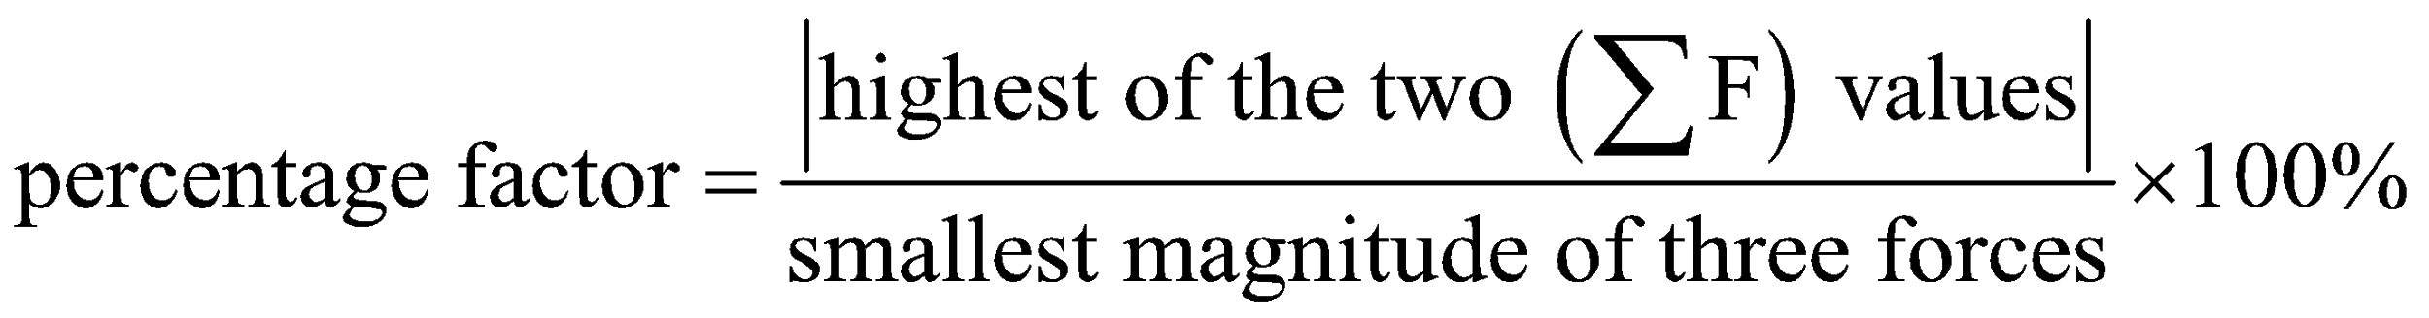

In this formula, the numerator is the absolute value of the highest value of the “sum” row of the table above, and the denominator is the smallest of the three forces. Look back at your table and the magnitudes of the three forces (masses). Hint: the first two forces were assumed to be exact, and the third one was found experimentally. Calculate percentage factor. Show all work.

1. Convert the magnitude of  to its newton equivalent. Show work.
2. What is responsible for this error? What can be done to minimize the error in the future? Remember, there is no such thing as “human error”!